Google Cloud Networking

 The most important component of network architecture in the GCP is Virtual Private Cloud

 VPC networks are global resources i.e. a single vpc can span multiple regions without communicating over public internet

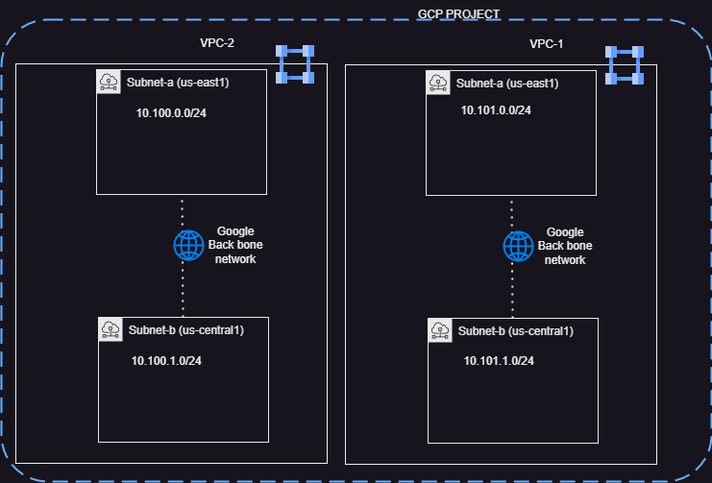

 VPC networks do not define IP address ranges, Instead each VPC Network is comprised of one or more partitions called subnets and each subnet defines one or more IP ranges

 Subnet are regional resources

 All compute resources of your workload rely on vpc networks routing capabilities for communication.  VPC by default connects the resources to each other

 Factors effecting the design of overall network architecture

 Do you need zonal, regional or global redundancy for resources (compute, storage)  Are high performance and low latency must have characteristics of your workload

Does your workload use sensitive data that must be protected in transit in use and at rest?  Does your workload need to operate in hybrid environment



High Availability, Failover and Disaster Recover Strategies



**GCP Service Locality**

**Examples Availability**

**Design Goal**

**Implied**

**Downtime**

**GCP Service Locality**

**Examples Availability**

**Design Goal**

**Implied**

**Downtime**

Zonal Compute Engine, Persistent Disk 99.9% 8.75

hours/year

Regional Regional cloud storage, Replicated Persistent Disk, Regional GKE

99.99% 52

minutes/year

 [Refer Here](https://cloud.google.com/architecture/disaster-recovery) for Disaster recovery

# Create our first vpc

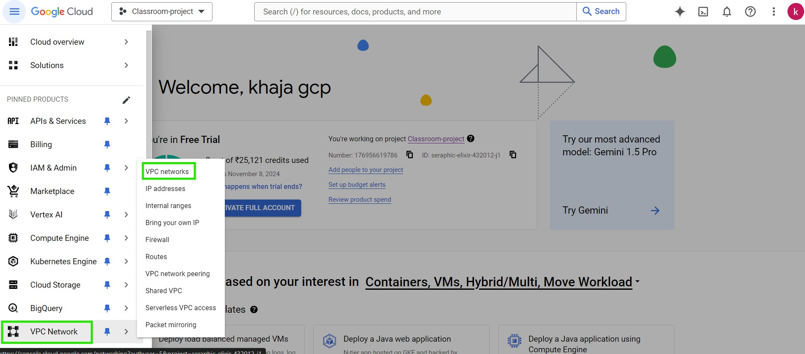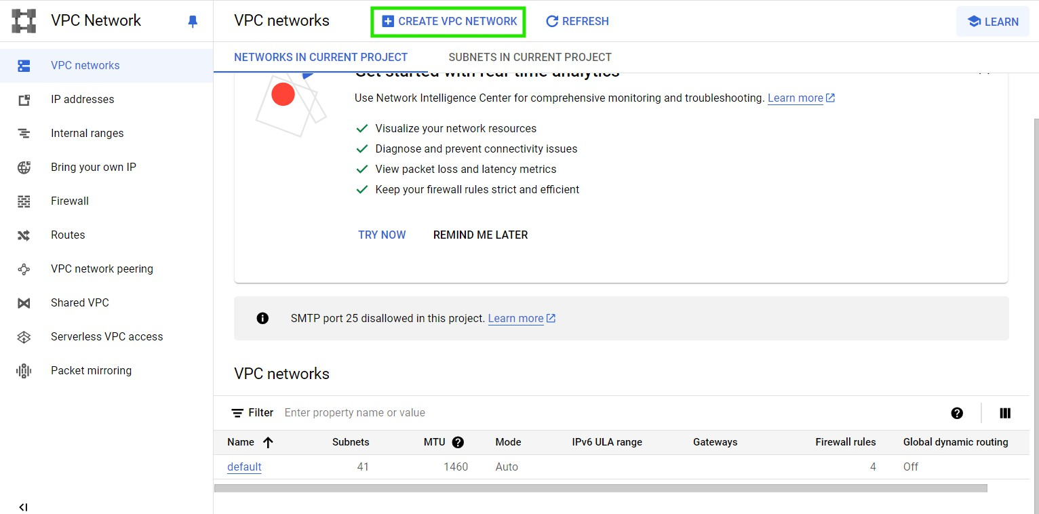 Lets create a network

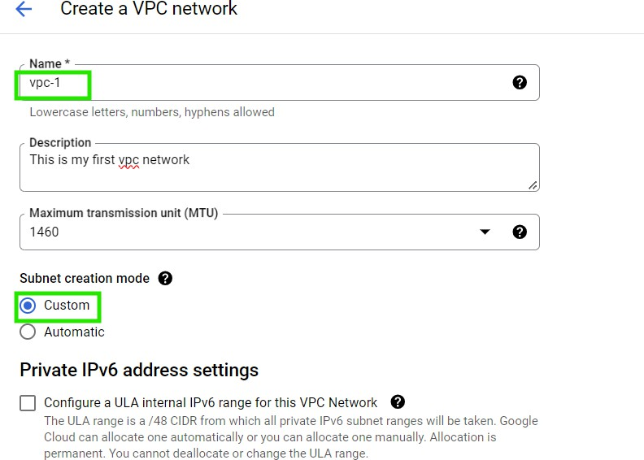

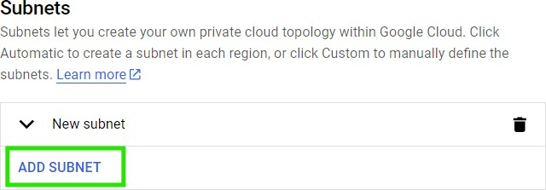

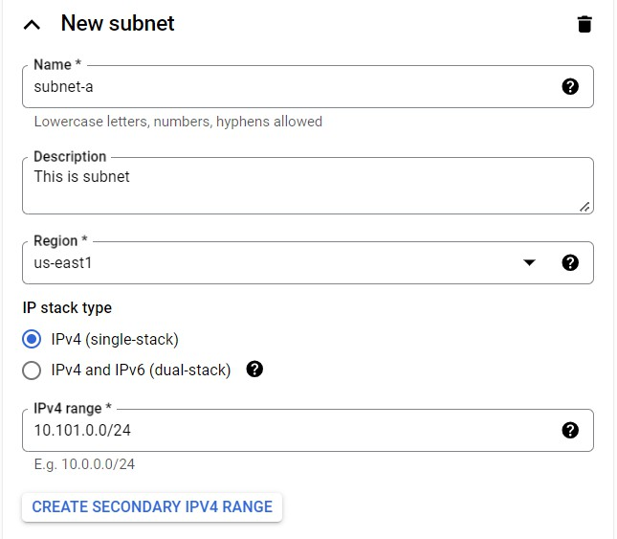

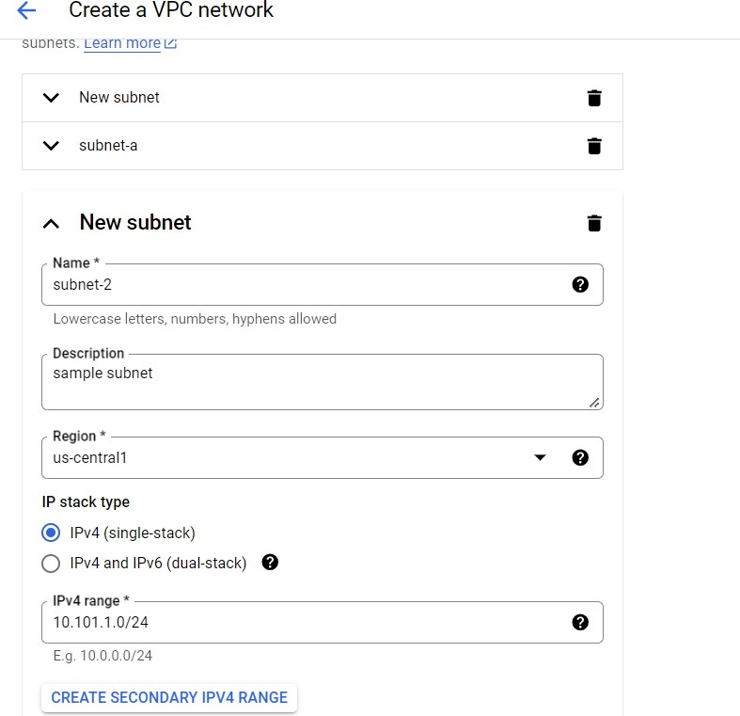

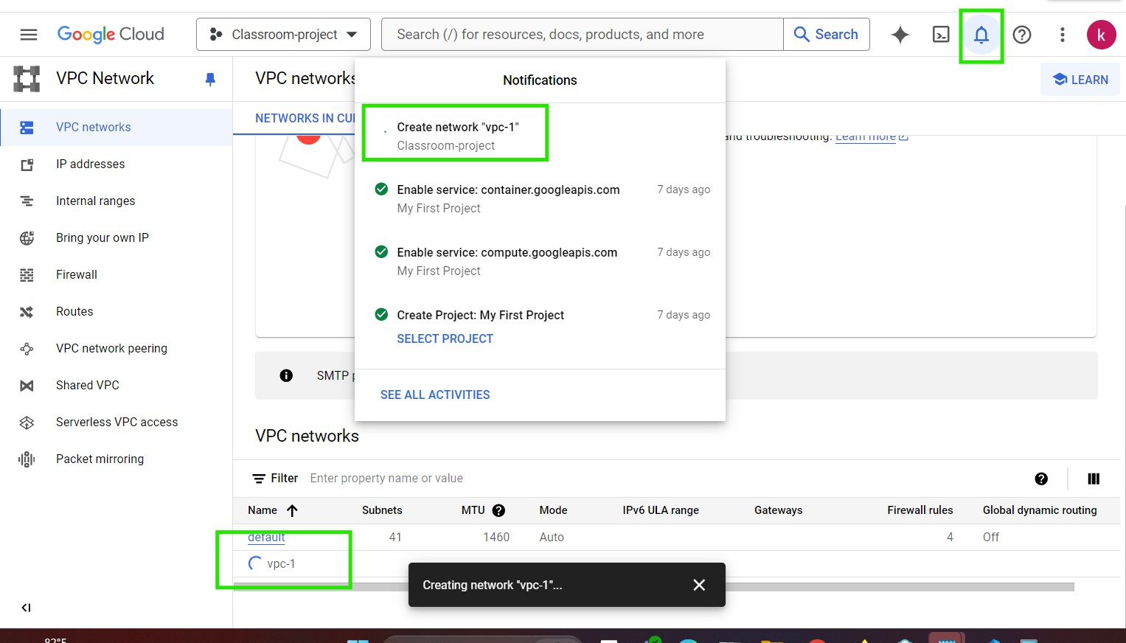

# default vpc

 GCP project will have a default vpc which is auto created.  GCP default vpc will have subnets in all regions

 This is generally used for compute instances where you donot want to create network.

# Let’s create a Linux VM in default vpc

 For screenshots watch class room video

# Let’s create a Linux VM in our vpc

 For screenshots watch class room video

# A sample application architecture

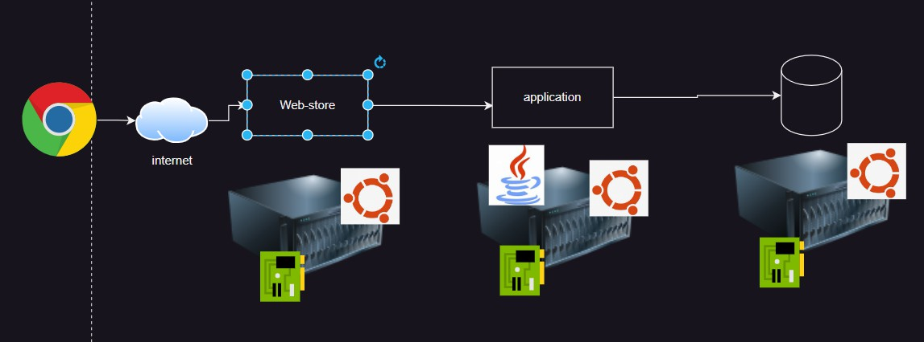 Consider the below simple three tier architecture

 Web tier is exposed to the internet i.e. this requires a public ip address

 How do organizations run three tier applications on-premises and how does the web store get an public ip address

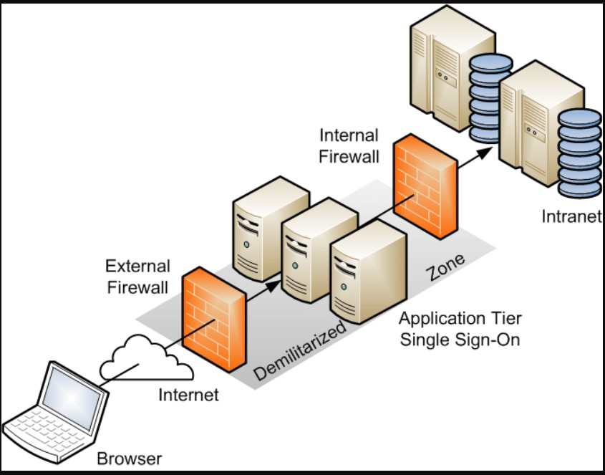Solution: DMZ